B2B Enablement: Registry and Gateway

# Objective

* To enable Business to Business(B2B) transactions in ONDC.
* To document and assess the changes required for the same in registry and gateway.

# Introduction

Currently ONDC is operational for Business to Consumer(B2C) type of transactions for few domains. ONDC wishes to enable both B2B and B2C use cases for same/different domain(s) in the network. The same is proposed by incorporating few additional constraints and information which are required in case of B2B transactions.

B2B specifications defined are based on a newer version of the specification while the existing B2C network participants are on core version 1.1.0 of the specification. Since there is a change in version of the specification across B2C & B2B, separate domain code for B2B transactions are being proposed during the initial phase so that B2B participants can be on boarded on to the network quickly without any impact to the network (that is, existing B2C operations).

Later, the current operational B2C specifications needs to be upgraded and post that a detailed migration plan should be put in to place for merging the B2B and B2C network participants on to the same domain.

During the initial phase, B2B apps will not interact with B2C apps in the network and vice versa. The solution definition for the same is outlined in the upcoming section. Impact analysis for the same is also given below.

# Assumptions

* For the initial phase, the new B2B applications will have domains that are mutually exclusive. Example: A single network participant (with multiple seller on records) will only be part of say either ONDC:RET10 or ONDC:RET14 but not both.
* B2C applications will not use the RET codes and will only use the nic codes.
* B2B applications will not use the nic codes and will only use the RET codes.

# Proposed Solution

* For all transaction APIs retail B2C applications will continue using domain as **nic2004:52110** (retail) and core version as **1.1.0** in **context**. Similarly they will continue to be registered with above mentioned domain code in the registry as well.
* Newly added B2B applications that will be on boarded to the network will use **core_version** as 2.0.0 in context for all transaction APIs. They will use RET domain codes in context for all transaction APIs and similarly will be subscribed in the registry as below:

|  |  |
| --- | --- |
| **Domain** | **Code** |
| Grocery | ONDC:RET10 |
| F&B | ONDC:RET11 |
| Fashion | ONDC:RET12 |
| BPC | ONDC:RET13 |
| Electronics | ONDC:RET14 |
| Electricals | ONDC:RET15 |
| Home & Decor | ONDC:RET16 |
| Pharma | ONDC:RET17 |
| Agriculture | ONDC:RET18 |
| Mobility | ONDC:RET19 |
| Logistics | ONDC:RET1A |

At this phase the participants in the network can be summarized as below:

|  |  |  |
| --- | --- | --- |
| **Participant Type** | **Domain code** | **Version** |
| B2C | nic2004:52110 | 1.1.0 |
| B2B | ONDC:RET10/11/14 | 2.0.0 |

As per the tables above B2C participants and B2B participants will be subscribed under different domains in the registry. They will be using different version numbers and domain codes in the context objects as well. As a consequence, any search result initiated by a B2C buyer app will only be fanned out to other B2C seller apps by the gateway as only they would have the same domain code. Similarly, any search result initiated by a B2B buyer app will only be fanned out to other B2B seller apps by the gateway for the same reason. Since this separation happens during discovery phase itself, there will be no interaction between B2B participants and B2C participants.

A single network participant will be able to subscribe for multiple domains in the registry.

# Development Changes:

1. Following domain codes are to be added in the property file of registry.

|  |  |
| --- | --- |
| **Domain** | **Code** |
| Grocery | ONDC:RET10 |
| Electronics | ONDC:RET14 |

1. Following configuration needs to be updated in the gateway & adaptor yml file after new domains are added:

startup:

domains: nic2004:52110,nic2004:60232,ONDC:RET10,ONDC:RET14

1. No change in rest of the code. No validation for “core_version” needed as it does not impact search operations in any manner.
2. Commented the code in registry for domain validation which is currently based on the constant map domain Hash map. This would be done directly based on the properties file.

# Impact Analysis

A new version of the specifications and several new domain codes will be introduced as part of the enablement process for B2B transactions. Impact analysis for the gateway and registry has been carried out.

## Gateway

The domain code and core_version of all requests are present in the context object of HTTP request JSON. The gateway peeks into the context object of the request to determine the logic for fanning out or forwarding the request.

The gateway presently checks if the following fields in context are present or not:

* transaction_id
* message_id
* domain
* city
* action

If any of the above fields are not present the gateway will returns NACK.

No validation of the values of any fields are currently present in the gateway. Hence, having new values for domain and core_version will not impact how the gateway currently functions. Hence no code change or configuration change is required at the gateway.

The gateway uses domain values for caching. In this case a list of domains are used for the same. The same has been added in the gateway.

## Registry

A master list of all the domains are maintained as configuration in the Registry. The new RET domain codes will also need to be added here.

Since specification version is not tracked at the registry there will be no impact due to the version upgrade.

### Subscribe flow

With the above changes there will not be any code changes required for subscription. The newly added domain codes will be configured and post that anyone will be able to subscribe using the new domain codes.

A single network participant can subscribe for several domains as well. It will have one record at the **entity_master** table with a record each for each domain in the **network_participant_master** table. Since **seller_on_record_master** has a many to one relation with **network_participant_master** table each seller on record will have a specific domain. If a network participant has multiple domains then their seller on records will belong to one of those domains only, not all.

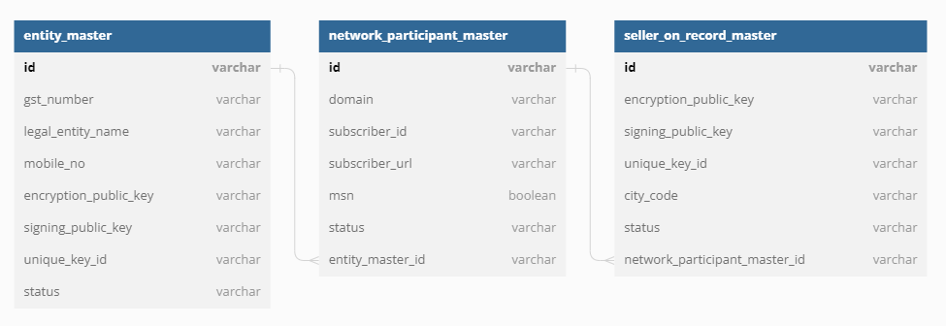

The same construct is currently being used for a network participant being a seller app on the retail domain and buyer app on the logistics domain. So no new changes need to be made to support the same with the addition of new domains. Hence there will be no changes required in the subscription flow.

For the initial phase, the B2B applications will have only one domain registered.

The only change required for this will be addition of the new domain codes in the master list that registry maintains in its configuration.

### Lookups

There is currently no validation based on domain search input in the registry look up APIs. Hence there will be no impact here.

# On boarding and Testing

New B2B network participants can join using the /subscribe endpoint and register themselves as well the SORs. Since amendment scenarios are currently not supported in the registry, new domain and SORs for existing network participants who wants to register in B2B will be registered by the support team post approval from ONDC as they currently do.

The addition of the network participants and SORs will be done in PreProd and all network participants will be tested in PreProd before approving movement to Production.

Tests must be conducted to ensure current operation is not affected.

# Expected Output:

1. New B2B Network Participants will subscribe to **only one** of the new domains as added using the /subscribe api as the current B2C network participants do.
2. Registry will onboard the B2B network participants without any issues.
3. When the new B2B network participants hit /lookup, the registry should revert back with the corresponding newly added network participants. No change in experience for existing participants.
4. Search request for new B2B NPs must mention include following points in the context so that the request is sent to the network participants from the same domain.
   1. Domain should be corresponding newly added domain of the new B2B NP
   2. “core version” should be 2.0 for B2B NPs instead of currently used version 1.1
5. On_search will have no change in operation.
6. Application to support option of older domains as per current functioning along with new domains and requests.

# Conclusion

* Configuration change required at the Gateway as well as Registry.
* Commented the code in registry for domain validation which is currently based on the constant map domain Hash map. This would be done directly based on the properties file. Same was raised during the testing.
* New domain codes need to be added in registry and Gateway configuration.

Post version upgrade of B2C specifications, merging of the domains needs to be done.

# References

* [List of domains - Google Sheets](https://docs.google.com/spreadsheets/d/1Rj7Hqdvmzup5kAvzbW15NgX5dV4U8c7DtvFopCW_9cc/edit#gid=0) | Published by ONDC in [Published : API Specs and resources](https://drive.google.com/drive/folders/1um7COKAs2hahHJOEqFnan1B5EFXvpMty) shared folder